C++

Instructions:

1. There are four questions in this exam.
2. Read each question carefully before writing your answer.
3. **Minor syntax errors will be ignored** (i.e. missing semi-colons) **but you will lose points for significant errors** (i.e. forgetting return type for a method, a semicolon that completely changes a loop, etc.)

**Question 1**

Convert the provided Java program in C++. The Java program (pattern.zip) is attached to the exam on ReggieNet. When you unzip the pattern.zip, the folder “pattern”, can be treated as a Java package. You can import the package into any Java project.

**Question 2 (30)**:

1. What happens when you execute the following C++ program? **(5 points)** Explain your answer in detail. **(10 points)**

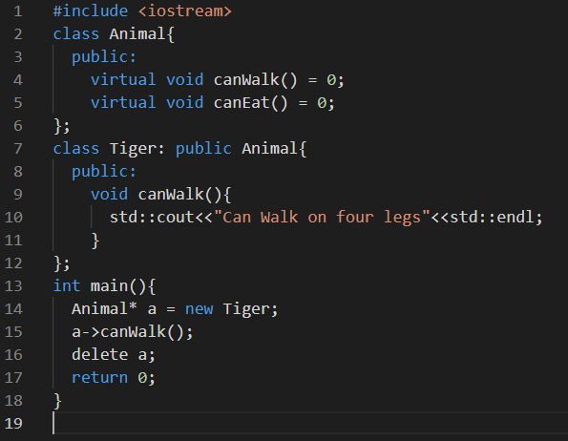

The program will not run.The error message will be that the Tiger does not name a type. This is because of the invalid expression for the abstract class Animal. The error occur at the “new” operator when we tried to create an object of the abstract class. Also the functions in the Animal class are pure virtual within Tiger. This raises the error. We also need to include using namespace std.

1. Explain the difference between reference and pointer in C++ **(15 points)**.
2. The difference are that, a pointer can be initialized without pointing to any variable, but a reference should be initialized to a variable. Also, a pointer can be re-assigned but references cannot be reassigned.  
   Further, pointer has its own memory address but references do not. A pointer can also be NULL called null pointer but a reference cannot be null. A pointer can point to another pointer but this is not the case in references. Lastly a pointer arithmetic is valid but reference arithmetic is not.

**Question 3**

1. Complete the main function for the following C++ program. What statement would you write at line 21 and line 24. **(15 points).**

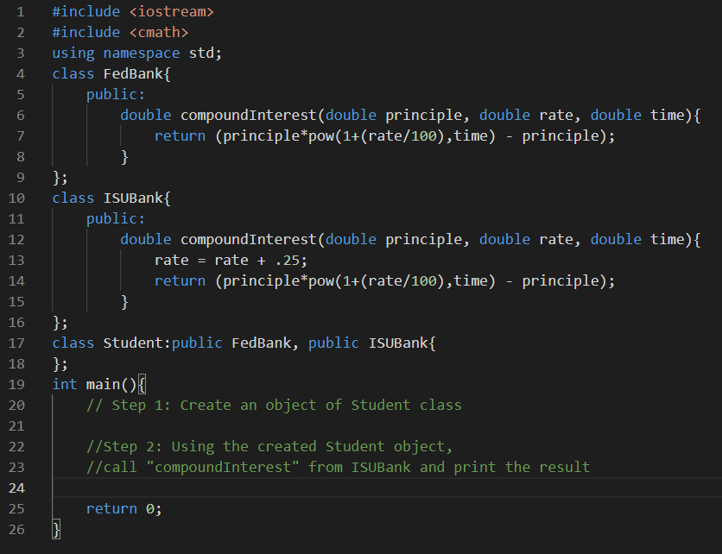

Student s*;

S= new ISUBank()

Cout<<”The compound interest from ISU is”<<s->compountInterest(10.5, 5, 4)<<endl;

1. When would use pass-by-value vs. pass-by-reference? **(15 points)**

We use pass-by-value when we want to copy the values of the arguments into the function parameter. Here the arguments are never changed by the function being called.

We use pass-by-reference when we want to pass the argument’s references into the function’s parameter. We use & symbol with the function parameter for that.

**Question 4**

1. What is “Diamond Problem” in C++? **(10pts)** Explain how to solve it by using an example? **(5 pts)**

The diamond problem is caused due to multiple inheritance. Example, an Animal class is been inherited by Lion and Tiger classes, and a Liger class inherit from the Tiger and Lion classes. To solve this problem, use virtual keyword on the inheritance of both Tiger and Lion. Example: class Tiger: virtual public Animal; Class Lion: virtual public Animal. Also, make the destructor of Animal class virtual. Eg virtual~Animal(){}

This will help our code to be able to invoke the constructors and destructors of all classes we are woking with when needed.

1. What is output of the following program? Explainyour answer **(10pts)?**  Does this program have any memory leak? If yes, where is the leak (mention the line numbers), why is it a leak and how to fix it? If no there are no leaks, why aren’t they any **(15 points)**

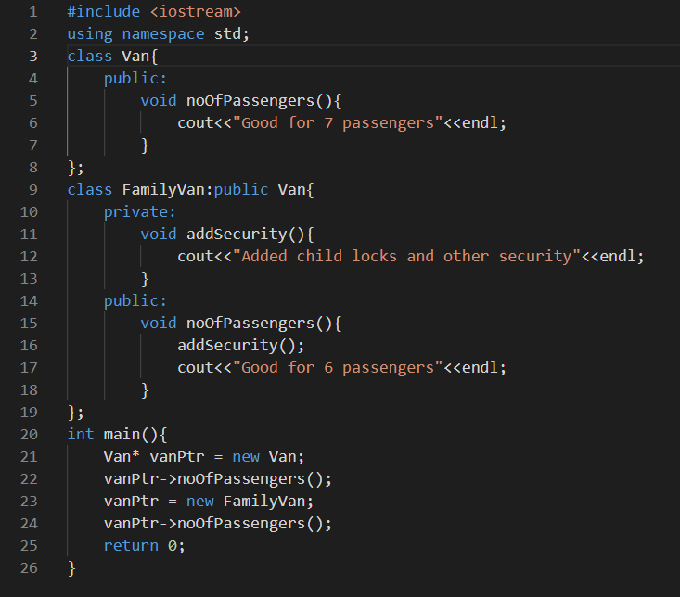

The output will be: Good for 7 passengers

There will be a memory leak because the pointer *VanPtr is not used to free the memory using the delete key word before reassigning it to the other object of FamilyVan. We loose the memory of the first pointer so if the first pointer is called there will be an error message. The first pointer no more hold the memory but still holds the value. The leak is at line 22 moving into 23.